**Lab 2 Report**

Following screenshot represents the output file of the sensor tag saved in android mobile phone. For this Lab, I have considered Humidity, Humabient Temperature, Latitude Longitude, Accelerometer values x, y, z. I saved the log file in the order of Latitude, Longitude, Date, X, Y, Z, Humidity, Humabient temperature.

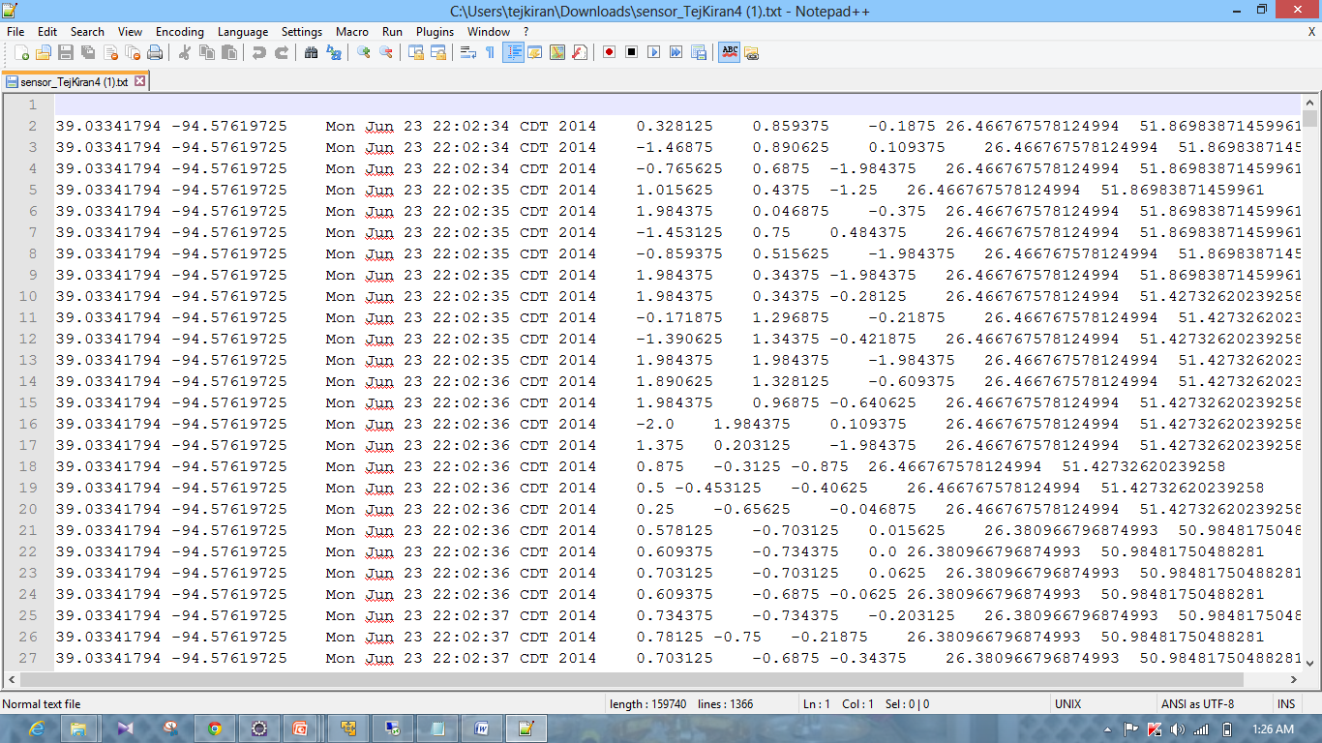

**HBASE**

**Create Table:**

Following screenshot represents the jave code for create table. I have done HBASE task in my local cloudera in Virtual Machine.

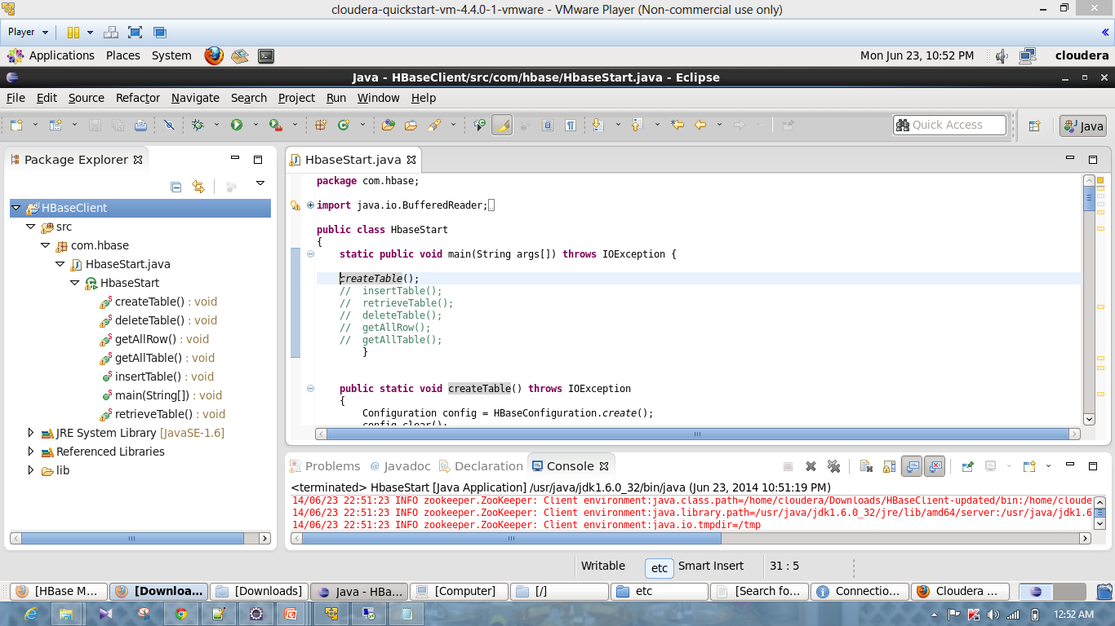

Following Screenshot represents the created table in HBASE master page of local cloudera.

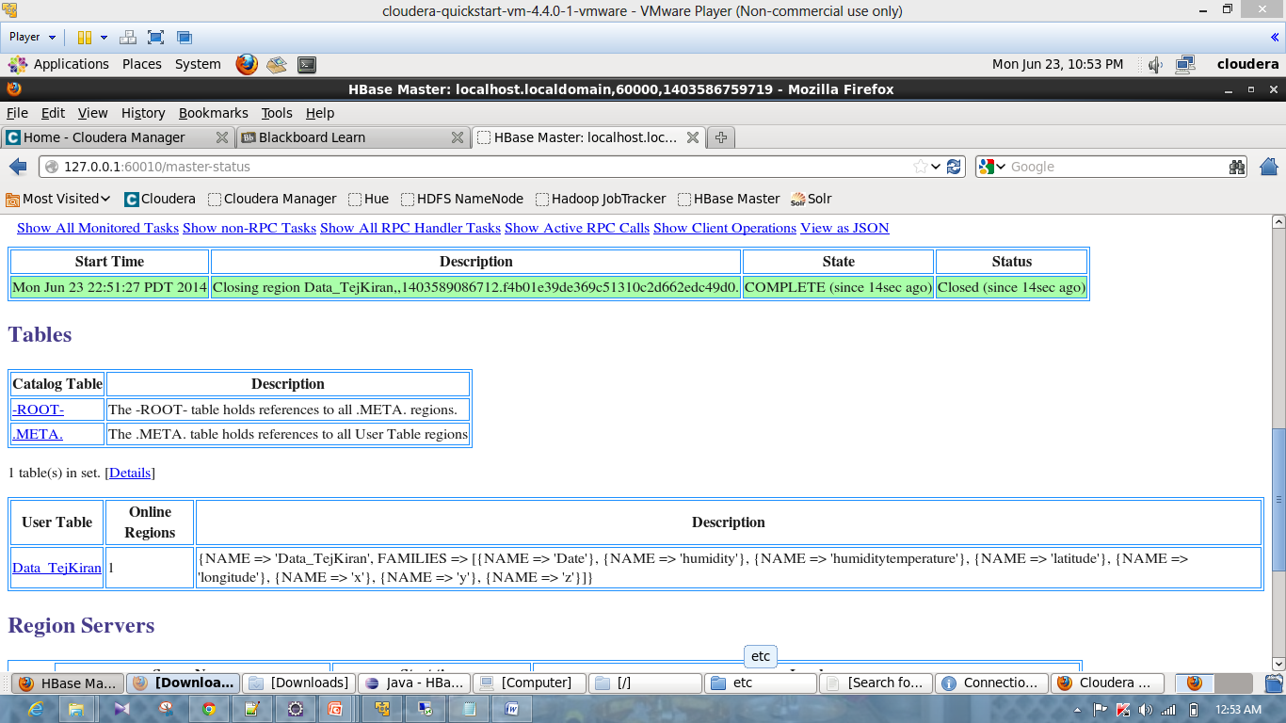

Insert Table (Push Data):

Following screenshot represents the execution of Insert Table code in eclipse.

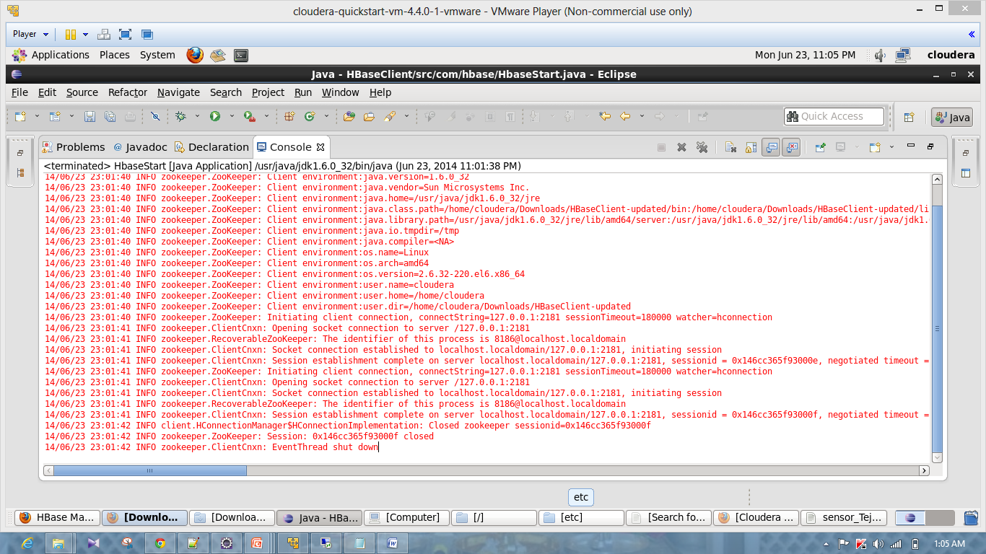

**Retrieve Row:**

Following screenshot represents the retrieval of one row from the table Data_TejKiran in HBASE.

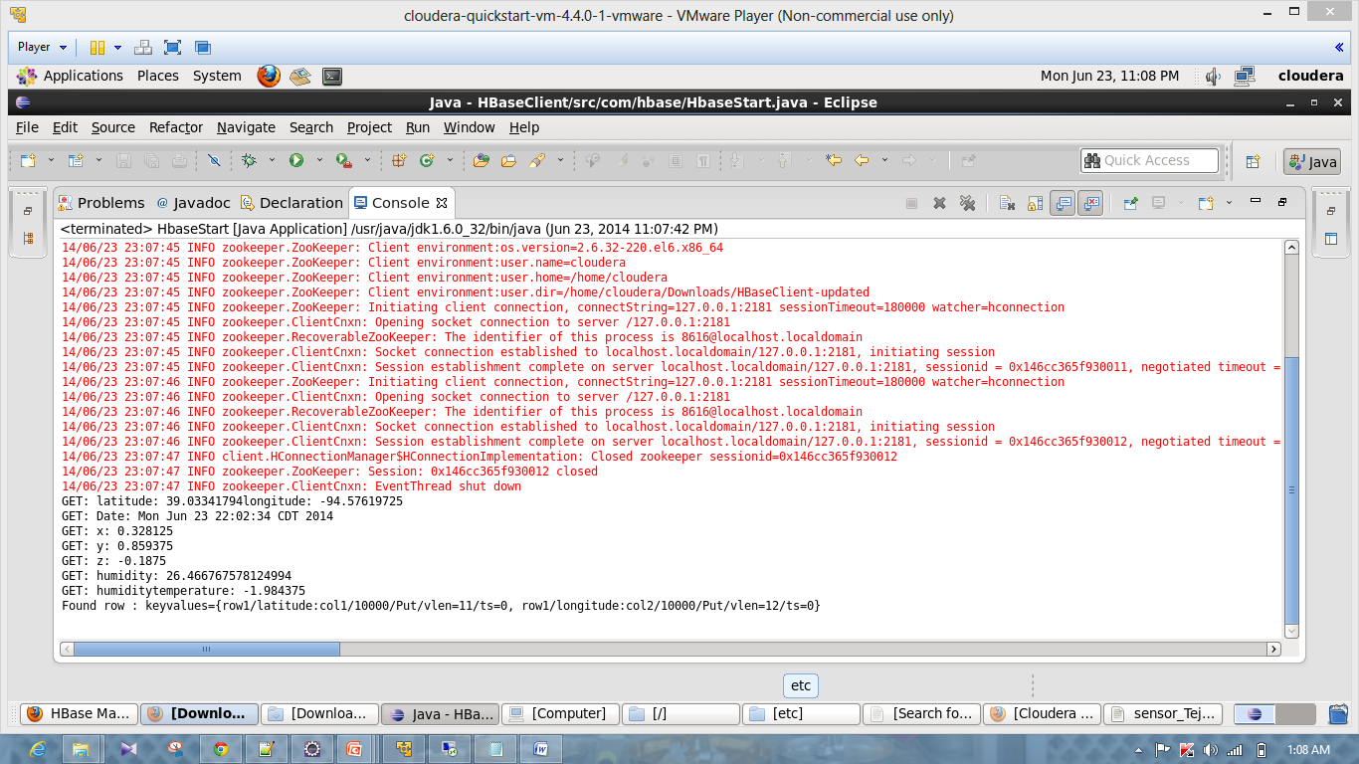

**Get all rows:**

Following screenshot represents the retrieval of all rows from the table Data_TejKiran in HBASE.

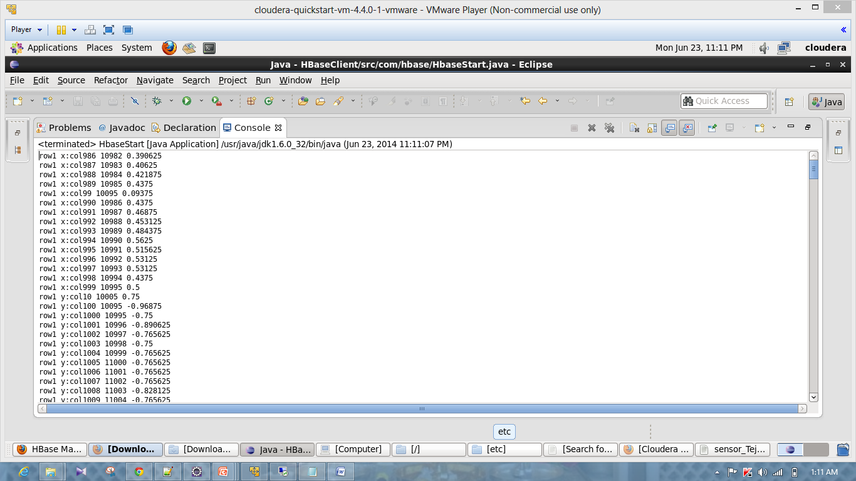

**Get all table:**

Following screenshot represents the output after the execution of Get all Table code from Data_TejKiran table in HBASE.

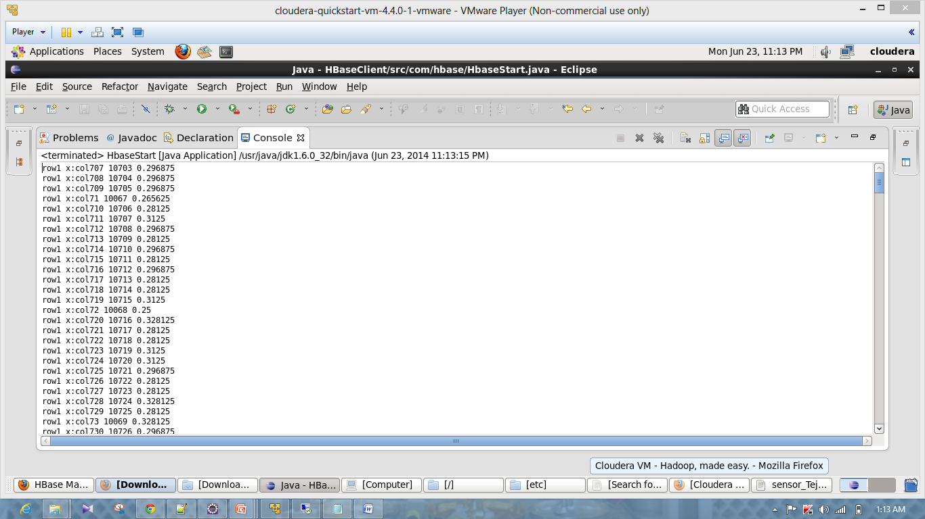

**Delete Table:**

Following screenshot represents the HBASE master before executing the Delete Table code.

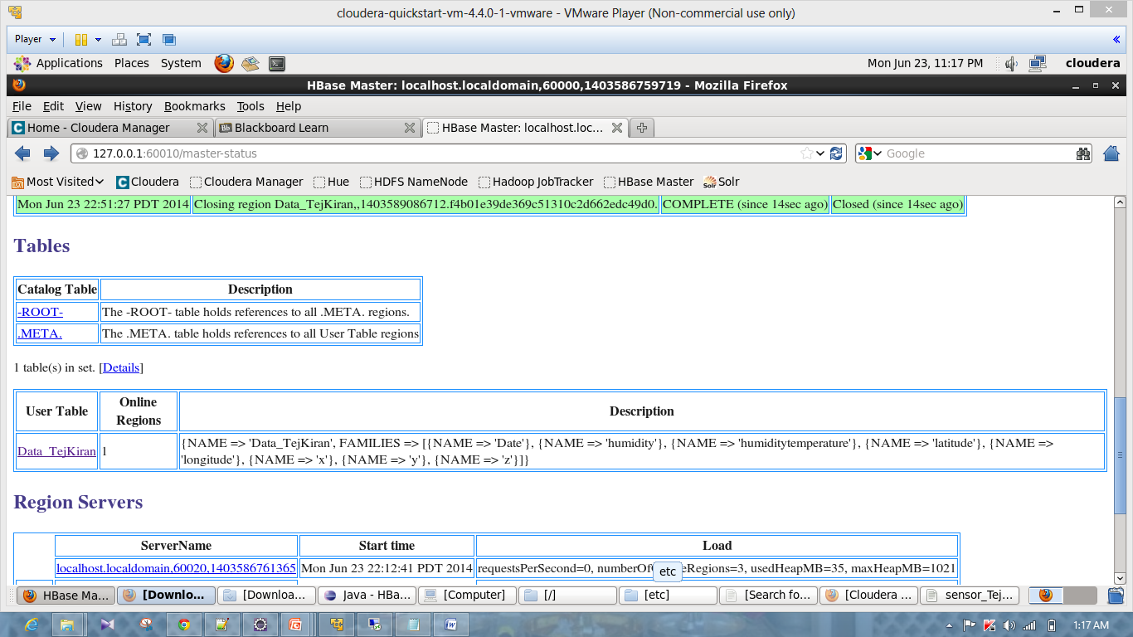

Following Screen shot represents the output after execution of Delete Table code in Eclipse.

